* How does your script work?

Python script needs two parameters to schedule itself to record the current time in UTC and validated_ledger.seq from the server_info command that is periodically called by script.

|  |  |  |
| --- | --- | --- |
| Variables | description | Values |
| polling_interval | Interval to call server_info | 2 seconds |
| time_interval | Time span till the script schedule to execute | 60 seconds |
| Plot_file | Path and file name to generate data file for plotting | Plot_datafile_<2334> +.dat |

Script call server_info command in every 2 seconds to gather information about the set of validated ledgers that target rippled has received. Scheduler executes till 60 seconds then record min, max and average time between validated ledgers before exists.

Environment:

Python version 3.8

Libraries: requests, os, sched, datetime and time.

Script generates two file

1. Plot data file with sample name - Plot_datafile_443007.dat (gitHub)
2. Record min, max and avg time between validated records. Sample file name - Plot_datafile_443007.datvalidated_time.txt (gitHub)

Script name: Rippled_server_info_ChallengeScript.py (gitHub)

* How did you decide on your polling interval?

Based on the requirement to visualize increment in validated ledger sequence over time, decide min time based on the observation and calculation that is 2 seconds, which is between validated ledger target ripple received.

Executed script on different polling intervals to collect the minimum time takes between validated ledger sequences.

* What do the results tell you?

Result for visualization generated from gnuplot.

gnuplot_commands.txt (gitHub)

Rippled_Plot.emf (gitHub)

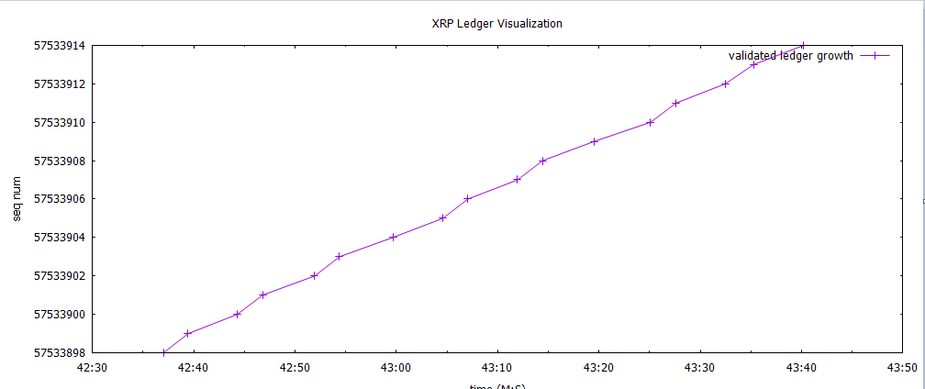

Variation between ledger sequences, that is not consistent.

Ledger sequence growth observed in x-axis with time on y-axis.

* What might explain the variation in time between new ledgers?

Factors involve variation in time between new ledgers may include grouping and ordering of transactions by applying deterministic or consensus rules to avoid double spend problems may impact on variation in time.

**Bonus question #1:** Enhance your script to calculate the min, max, and average time that it took for a new ledger to be validated during the span of time captured.

Script extended to record min, max and average in file.

**Bonus question #2:** There are some other (better) ways that you could use the rippled API to find how long each ledger took to close/validate.

server_state API, could be the better option to find how long each ledger took.

<https://xrpl.org/server_state.html>